CSEN 60 Lab 3 Instructions

This lab is a continuation of lab 2. You will be styling another html view and creating a 3rd page from scratch based on the given mockups.

Before getting started

* Make a copy of your lab2 folder and rename it “lab3.” Make sure that lab3 is a child folder of labs, so the path would be csen60/labs/lab3.

Instructions

You have already styled all-articles.html from Lab 2. In this lab, your goal is to style the home and article pages to look like the following mockups ([home](https://drive.google.com/file/d/19kKXr05sZlhnsR_zppwibck4nBV4W7FR/view?usp=sharing) (index.html), [all-articles](https://drive.google.com/file/d/1FljAyFAX8rOSC7wZpM7VKiMU_I-ebAQr/view?usp=sharing), and [article](https://drive.google.com/file/d/1wM1BFoKoVwOXrZvTtDeHM_ugkDCQzwY7/view?usp=sharing) for larger viewing):

[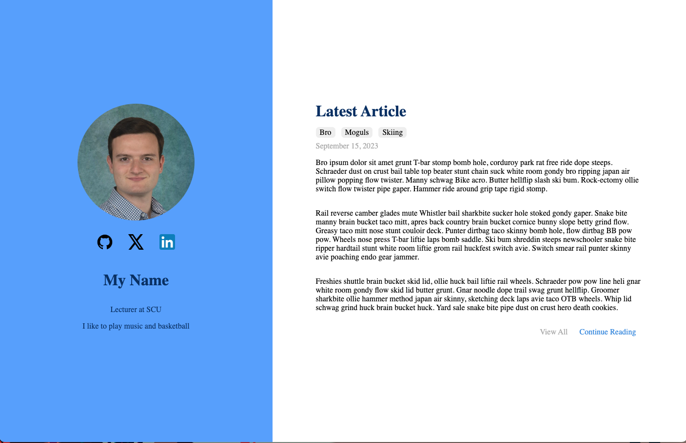](https://drive.google.com/file/d/19kKXr05sZlhnsR_zppwibck4nBV4W7FR/view?usp=sharing)

[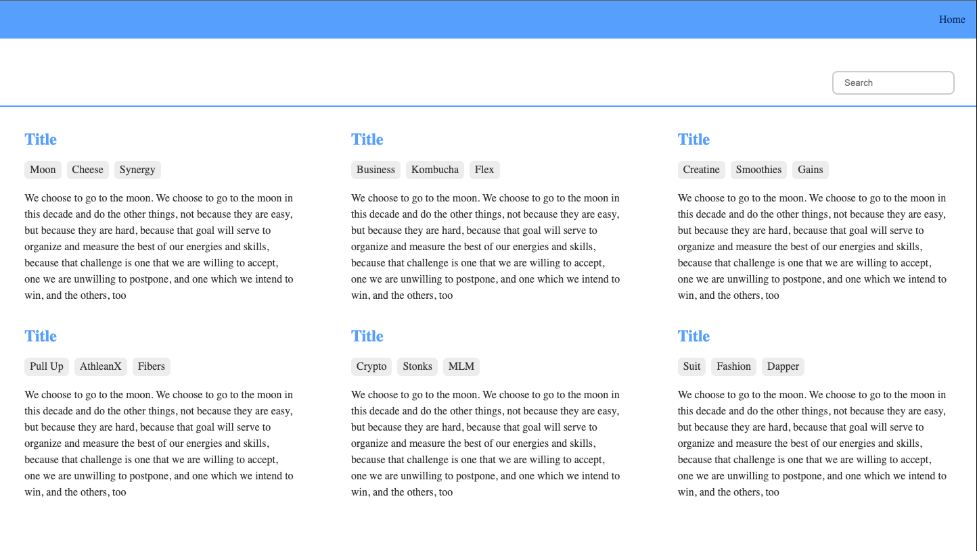](https://drive.google.com/file/d/1FljAyFAX8rOSC7wZpM7VKiMU_I-ebAQr/view?usp=sharing)

Clicking one of the titles takes you to the article:

[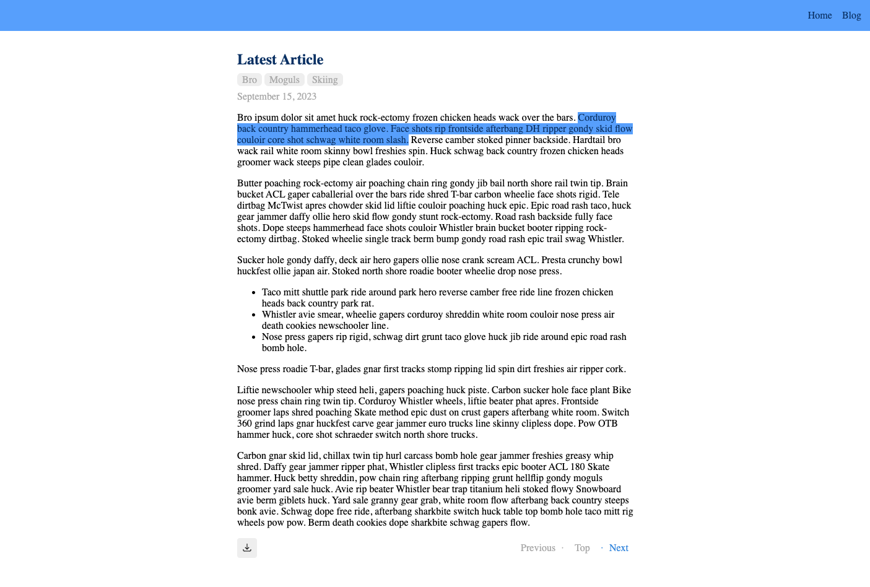](https://drive.google.com/file/d/1wM1BFoKoVwOXrZvTtDeHM_ugkDCQzwY7/view?usp=sharing)

You are given a complete index.html (home) and article.html on Camino ([also can be found here](https://drive.google.com/drive/folders/1V0ZIbS9WXsRaDoBdgk0Uc5wfuTT2RfGz?usp=drive_link)). Download the html files and add them to your lab3 folder. Create an index.css and article.css to style each page. Reuse base.css stylings across the new html pages. Don’t forget to link base.css and the specific css file for the new html pages.

Images

You’ll be using 4 images on the index.html page.

* In your lab3 folder, create an “images” folder.
* In the images folder, a profile picture for yourself. It can be a real picture or an avatar/pic-art.
* Search and add 3 company logos (Github, X, and LinkedIn). You could use different logos if you like.

Tips:

* Link your CSS files in the html. Base.css should be first.
* Reuse base.css styles in your new html pages.
* For index.html, set the body width and height to 100vw and 100vh respectively so the content takes up the entire page.

Demo and Submission

* Show the TA your website to receive demo credit.
  + Demo will involve clicking on links to travel from page to page.
* Commit all the changes you made to your git repository and push those changes to github
* Submit the Github link to the lab3 assignment.

# Grading Criteria

| **Criteria** | **Points** |
| --- | --- |
| Correct visual styling of index.html and article.html | 70 |
| Index.css and article.css implementation | 20 |
| Demo | 10 |